**(Camera Shop And Rent) Management System**

**Submitted By -**

Name - Srabon Bhowmik Shanto

ID : 161-115-140

Name -Sadia Hasnat Mishel

ID : 151-115-095

**Submitted To -**

Name :

Lecturer, Metropolitan University



**Department of Computer Engineering**

**Metropolitan University ,Sylhet ,Bangladesh**

July, 2018

**Date of Submission :**

**16th July , 2018**

**Project Summary**

This is a information and record based project which is capable of storing and exchanging all the information among the staffs or even to the users of a certain camera shop.

- On maintenance of a camera shop it is needed to record or store the information about which products are available to shop , which are in stock and which are upcoming. Even it is necessary of keeping record of the valuable customers who buy products from the shop as well as rented a product form the shop. It is also necessary of keeping details of the available showrooms and customer cares of that shop .

- Addressing above needs this projects has created and it offers user friendly interface for a user to store all above information on this . Such as , the information about product , customer , sell, rent , showroom and so on. It also offers the security of those stored information by user account .

- Hence , it is a user friendly interface based project it comes with lots of features like

**Security :**

* User login
* Creating user account
* Recovering user accounts
* Logout

**Data Entry :**

* Adding relevant information about products , customer.
* Taking records of who took product as rent
* after returning deleting the entity
* Details of showroom and customer care

**-** The advantage of this project is accessing saved data easily and storing them in a permanent database. For information security it comes with login and logout feature Recording of sells and rent products would be very easy. Any staffs can share the information about the shop with customers easily

-The Limitations are , it is a offline software project therefore online connectivity is absent. Manually inputs of information in database in desired . But pc connected with LAN will have all the time updated database if any one does any update.

**Chapter 1 :**

**Introduction**

Storing information or data in hard copy it is tiresome and might be insecure or they can be moved by others whom we do not want. Sometimes they might be exposed to hazards such as water or pests. To solve this issue data need to store securely and storing them virtually may be a good alternative.

On this project , it is done the same where data are stored securely and presence of data in hard copy is moved into database so that it can be accessed how we wanted to be accessed .

**1.1**

**Background**

The project making background is in java platform. We have used javaswing with the collaboration of database.

**1.2**

**Objectives**

Several following objectives are attached with this project

* easy data storing system
* changing them with desired process
* predefined record
* password securing
* saving data form hazard

**1.3**

**Hardware and Software**

The project building comes with following hardware requirement

* Desktop PC or Laptop
* Intel Dual core or above
* Ram 4gb or above
* Motherboard gigabyte G41RQ or above
* Monitor or LCD

and software requirements

* Windows XP or above
* Netbeans IDE 8 or above
* Java 8
* Window builder Plug-in
* Sqlite Manager
* Firefox 25 or less or above except Firefox quantum
* Adobe Photoshop CS4 or above
* Photoscape
* Microsoftword 2007 or above

**1.4**

**Technologies**

Although it is a data store and recording management system based project therefore DBMS technology is used .The essential feature of database technology is that it provides an Internal Representation of the External world of interest . As example, representation of a particular date , time, id , name , product quantity in any information control system.

For designing CGT ( Computer graphics Technology ) is used. Basically Adobe Photoshop and Photoscape is used to design the icon and the primary design of the UI.

**Chapter 2**

A short brief about the project is demonstrated in following

This project is divided in some several part like log in , sign up ,forgot password, home and so on.

**Login**

In login a user can have three option , login , sign up and recovering account option. If user is registered he can login but if not then he/she needs to register with sign up option.

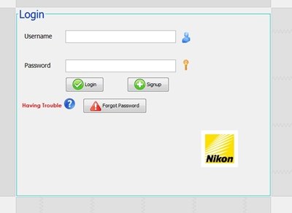

**Sign up**

In this section if any one wants to open an account they can open it buy providing some simple information like name , username, password. User must need to remember his/her username and password for further use.

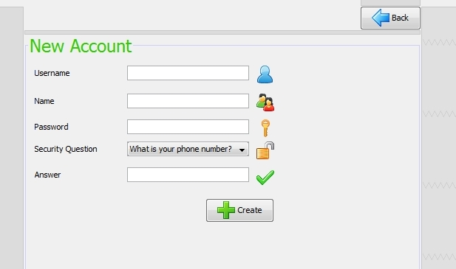

**Forgot Password**

This is used for recovering password of an user.

**Home**

This is the full menu of the project where all the function of the projects can be found.

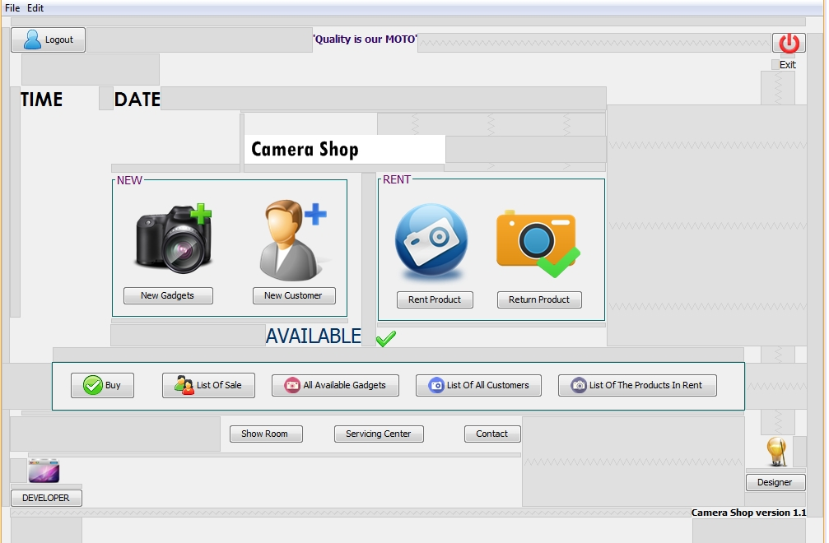

**New Gadgets and New Customer**

This section will take the record of new registered records about gadgets and customer

**Rent Products and Return Product**

On this part record of customer who rented a camera or returned it will take place

**Buy**

It will keep the records of the customer who buy a camera or accesories.

**List**

List will show all the data of selected filed in database like list of sale , list of all customer etc

**Time widgets**

This will show real system time in the main window of the project.

**Details**

Details about showroom , servicing center will be found in Showroom, Servicing Center field .

**Logout**

This will make logout of an logged in account

Also details about designer and developer would be found in designer and developer option.

**Chapter 3**

Coding of this project is made possible by java NetBeansIDE 8.2.

A glance about how the coding is done is in following

**Login Panel Code**

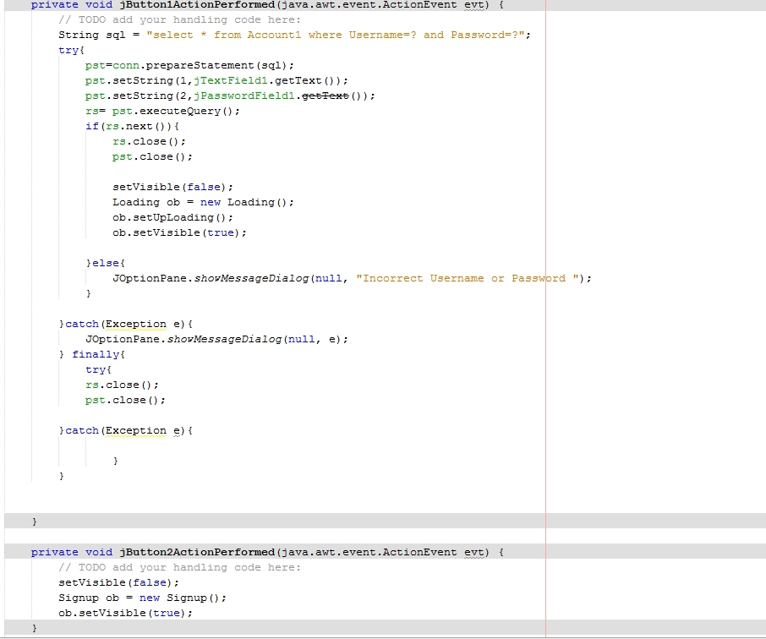

On login panel , for login it will take input from the user for username and password field.

After that if that is in the account1 table of our database it will check that. After executing the query the database will be closed and we will make login window disappear and call the loading window to appear .

**Sign up Panel Code**

In this panel if user want to open an account then user can open with . there is some textfiled which will take scan of the information and send it to the database to store.

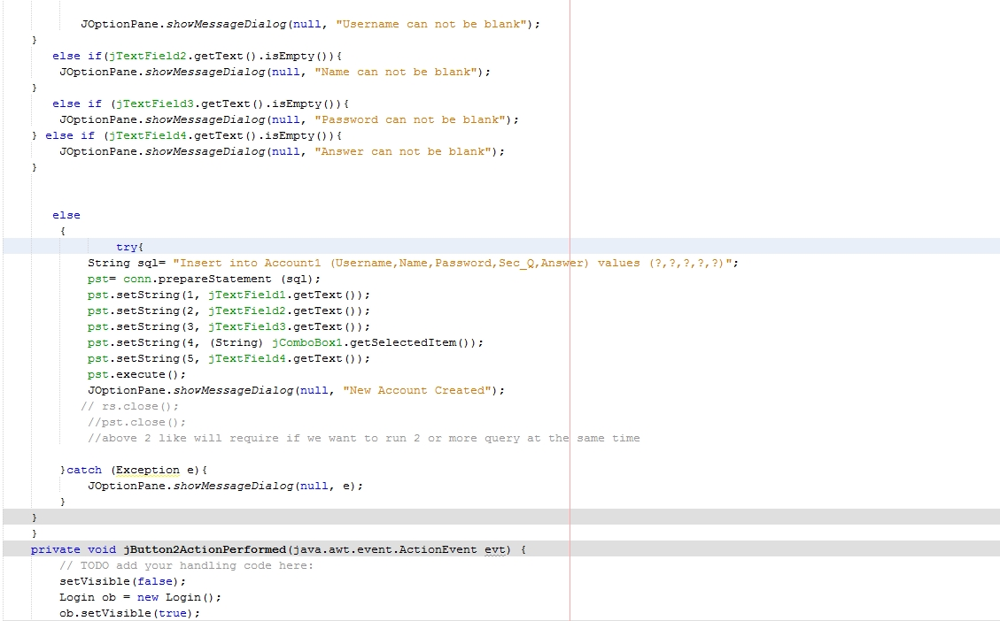

For any blank field it will not take the input . After successful insertion of those datum in database a message with appear with joptionpane that new account created.

**New Customer Panel Code**

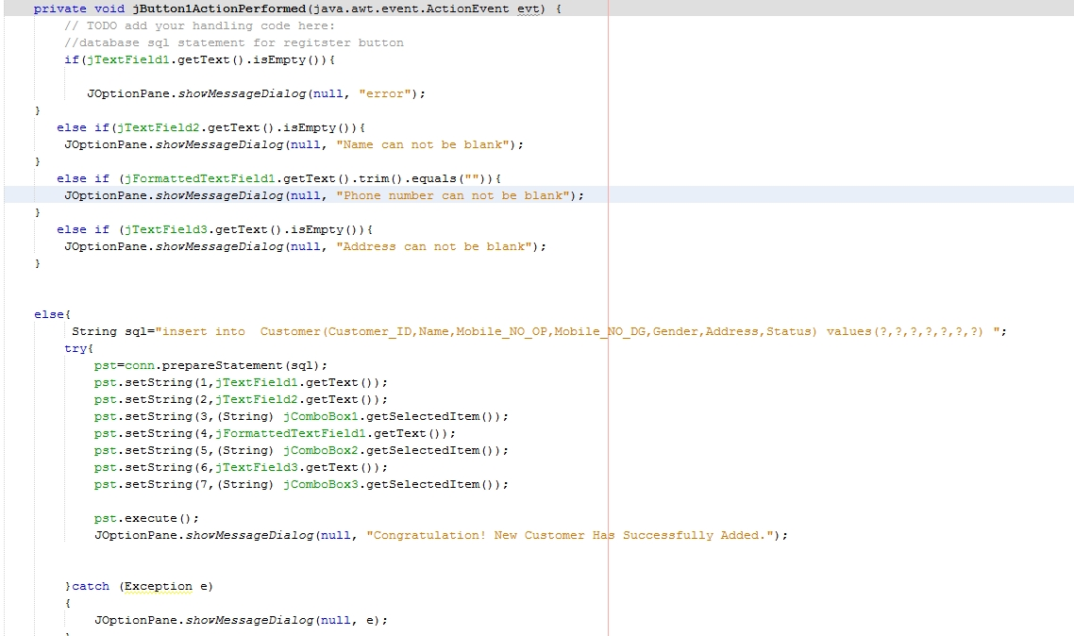

In several text field a customer will provide his information. with gettext every text will take as input and all will be inserted into customer table of the database.

**Chapter 4**

**Conclusion**

This project is capable enough to take record the information of a certain camera shop and also will save them from physical hazards. Storing and exchanging information will be more pleasing and easy with this

**Challenges**

For constructing this project it is needed to maintain the code sequence and proper syntax of the programming language .